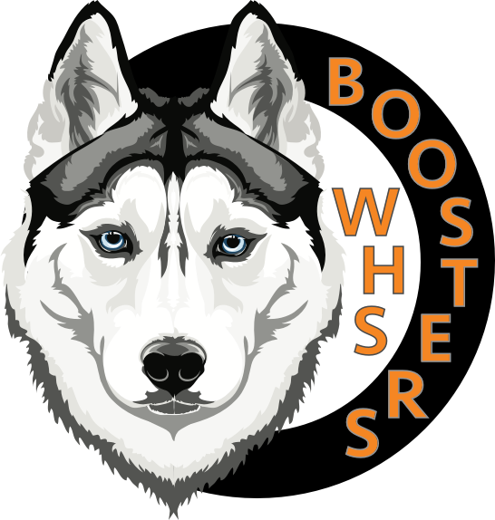
Washington High School Booster Club
Norm Stelle Scholarship 2021

Attach this cover sheet with required documents and
email to Boosters4whs@yahoo.com by May 3, 2021

Scholarship Criteria:
- Must be a Washington High School graduating senior during the current academic year, and must have completed at least one full season in a sport or currently active in a spring sport.
- Must be planning to attend a vocational school, community college or four year college/university and be enrolled within six months of receiving award.
- A check will be issued to recipient upon proof of registration of any qualified institution as listed in Item 2 above. Proof of registration must be presented to claim scholarship. The scholarship will be declared null and void if not redeemed by Sept 30.
- Must have a cumulative GPA of 2.5 or greater.
- Must be an active Booster Club member or child of a member as of March 31, 2021.

Application Instructions and Documents Required:
- Submit two (2) letters of recommendation: at least one must be from a coach or athletic director.
- Please include the following on a separate sheet of paper:
  - What sports have you participated in at Washington and for how many years? Please note at what level you played (i.e. Junior Varsity, Varsity….)
  - List any leadership positions held on your sports team (i.e. captain).
  - List any athletic awards won (i.e. All League, MVP, coach’s award….).
  - List your extracurricular activities (include employment).
- Please write an essay of 500 words or less describing your most memorable athletic experience at Washington.
- Include a copy of your WHS transcript (does not need to be an “official” copy)

Application Information:

Name: ____________________________________________________Cell Number:_____________________

Address:___________________________________________________________________________________

Email address:______________________________________________________________________________

College you plan to attend:____________________________________________________________________

Signature:____________________________________________________ Date:________________________

Please attach this page as the cover sheet of your scholarship application packet.
Email to Boosters4whs@yahoo.com by May 3, 2021

